A

PROPOSAL

ON

**MAINTENANCE**

**OF**

**KHOPASI HYDROPOWER PLANT**

SUBMITTED TO:

**NEPAL HYDROPOWER ASSOCIATION**

SUBMITTED BY:

**NEW RISING CONSTRUCTION PVT. LTD.**

ER. SURESH HUMAGAIN(45)

ER. SANJAYA TAMANG(40)

ER. SHYAM KHATIWADA(41)

ER. SANDEEP RAI(37)

DATE: 2072/04/29

# ACKNOWLEDGEMENT

We are thankful to all of the persons who helped us directly or indirectly during this proposal writing. And we would like to get suggestions if any regarding to this proposal.

We must acknowledge our deep gratitude to Manish Humagain for providing us time to collect the information about our proposal. As he is the worker of the Khopasi Hydropower Plant, his help in the proposal is tremendous.

Our special thanks go to Er. Raja Ram Rayamajhi for his support and helping us for different solutions and ideas that arereally necessary.

We are grateful to Er. Bisistha Raj Adhikari, a water resource engineer for his contribution for his supervision on water based disaster management and flood risk assessment.

Ramesh Kafle deserves thanks for his direct and indirect assistance during the preparation of this proposal. Especially we wish to thank Er. Krishna Hari Sitaula, a senior engineer of New Rising Construction Pvt. Ltd. for their suggestions, guidance and support during the proposal preparation.

Also we are very much grateful and thankful to New Rising Construction Pvt. Ltd. for providing the opportunity of preparing this proposal of the project.

# TABLE OF CONTENTS

I.ACKNOWLEDGEMENT ii

II.TABLE OF CONTENTS iii

III. LIST OF TABLES iv

IV. LIST OF FIGURES iv

V. ABSTRACT v

1. INTRODUCTION 1

2. STATEMENT OF PROBLEMS 2

3. OBJECTIVES OF THE PROJECT 3

4. LITERATURE REVIEW 3

5. METHODOLOGY 4

5.1 PRIMARY SOURCES OF DATA COLLECTION 4

5.1.1 OBSERVATIONS 4

5.1.2 SURVEY 4

5.1.3 QUESTIONNAIRS 4

5.1.3.1 INTERVIEW 5

5.2 SECONDARY SOURCES OF DATA COLLECTION 6

5.2.1 LIBRARY RECORDS 6

5.2.2 INTERNET 6

6. COST MANAGEMENT 7

6.1 MATERIALS 7

6.2 EQUIPMENTS 8

6.3 SALARIES OF PERSONNEL 8

6.4 TRANSPORTATION 8

7. TIME MANAGEMENT 9

7.1 MATERIALS 9

7.2 EQUIPMENTS 9

7.3 WEATHER 9

8. CONCLUSION 10

9. REFERENCES 11

# 

# LIST OF TABLES

Table No. 1 Cost management of the material 7

Table No. 2 Cost management of the equipment 8

# LIST OF FIGURES

Figure No. 1 Reservoir of the plant 1

Figure No. 2 Control station of the plant (observing the sight) 6

# ABSTRACT

This is the proposal for the maintenance of Khopasi Hydropower Plant.

As the plant was established many years ago, the parts are not working properly. We noticed that the two turbines of the plant are totally not working. The canal is having too many problems like seepage, leakage etc. So we must think upon the conditions of the plant strictly at the moment. Increasing problem of load shedding can be reduced in some instance by doing this project.

We are trying to make many solutions & ideas for this project. Lining of the canal, replacing the old parts, maintenance of the parts and observation of the total plant with fully consideration of economical work will be performed.

This project is of great essence in the time. This will help somehow in reducing the long time load shedding problem of the country. Establishment of the new hydropower plant takes long time and will cost heavy. Therefore, the immediate maintenance of the plant is very necessary at this instant.

Er. …………………….

# INTRODUCTION

This is the proposal for the maintenance of the Khopasi Hydropower Plant (KHP) situated at Khopasi, Kavrepalanchowk district of Bagmati zone, 35km East from the capital of the country. This project is proposed so as to enhance the output of this hydropower. The KHP is the third hydropower project constructed in Nepal. The power station was commissioned in 1965 B.S. The construction was started in 2017 BS and completed in 2022 BS. It has the capacity of 2.4 MW from three units of 0.8 MW each. The plant was completed with the assistance from the Soviet Union. This hydropower plant is totally dependent on Roshi Khola.This project is of great essence in this moment, as the load shedding is one of the great problem in present days. If the station runs in its full capacity, it can serve many houses and can minimize the load shedding in that area. As the new hydropower plant cannot be constructed instantly, simply maintaining the parts and replacing by new ones may be helpful for the proper operation of the KHP. I think Nepal Electricity Authority should think about this issue on time.

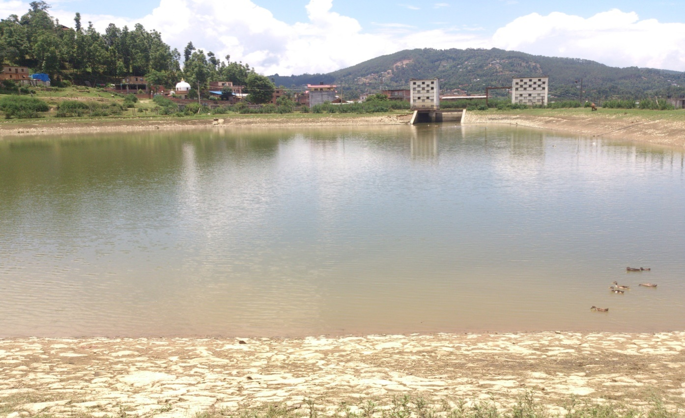

Figure 1 Reservoir of the plant

# STATEMENT OF PROBLEMS

1. From the news published on 29/08/2012, the capacity of the plant had been reduced to 400 KW only from the design capacity of 2.4 MW.
2. As the plant is getting old, due to unavailability of the maintenance and lack of technical persons, the plant is in the phase of closing.
3. Among three turbines, the only one is working properly at the present.
4. Other machine parts are also in the verge of failure as the parts are about 50 years old.
5. Locals are expressing aggression to the government and the present chief of this plant.
6. The water required for the plant is decreased due to leakage i.e. the local people are using the water for irrigation.
7. The drinking water projects are intending to take water from the same source which will also create problem in the production of the plant.
8. Water carrying canal is also old and the problems like seepage, infiltration is increasing.

# OBJECTIVES OF THE PROJECT

1. The turbines which are not working will be maintained by repairing if possible, otherwise they will be replaced by new ones.
2. The old parts which are installed about 50 years ago will be checked properly to know about their present condition, then by finding out the problems, the maintenance or new replacement will be done making the work economical.
3. To enhance the power production, if possible, more than 2.4 MW by newly installed highly efficient parts.
4. The use of the water by the local people from the canal for irrigation will be stopped providing them the best alternatives.
5. The canal will be maintained by lining to reduce the seepage loss.
6. The drinking water projects will be strictly banned through that source and the concerning parties will be told for the search of new source.
7. To increase the power production and to serve the houses as much as possible.
8. To check the leakage of electricity.

# LITERATURE REVIEW

While preparing this proposal, different books and news published are referred. The book on hydropower plant like *Principle of Hydropower, S.K Chand;Proposal on Feasibility of Hydropower Project, C.Lotti (1985); Mai Hydropower Project Feasibility Study by Sanima Hydropower (P) Ltd.*and other internet sites are preferred for this proposal.

# METHODOLOGY

To know the actual condition of the Khopasi Hydropower Plant and to solve the problems arose in the plant, different types of data will be collected. Collection of the data will be done in two categories: primary sources and secondary sources of data collection.

## PRIMARY SOURCES OF DATA COLLECTION

Primary source of data collection will be done by observing the condition of the hydropower. Our special technical team will be sent to observe the present status of the plant.

### OBSERVATIONS

First the site from canal to reservoir and condition of the plant will be recognized. Under this topography, necessity of the maintenance and its benefits will be known. The past information of the plant, present condition and the problems that may arise in future will be totally investigated.

### SURVEY

In accordance with the observation, there may be the problem of flooding, landslides, mass wasting at the upstream site of the plant, geological and geo- technical problems in the project area and field sediment gauging problem of the available sediment in the reservoir. So the site will be totally investigated in two steps: preliminary investigation and detail investigation.

### QUESTIONNARIES

It is the process of obtaining the information from the person directly by means of number of queries. Here, we will have the objective type and subjective type of questions: objective type for the consumers and subjective type for the specialist asking about their satisfaction and to get the ideas related for the solution of the problems.

Model of objective type questions

Put the tick marks if the statement is appropriate.

YES / NO

|  |  |  |
| --- | --- | --- |
| **1)** |  |  |
| **2)** |  |  |
| **3)** |  |  |
| **4)** |  |  |
| **5)** |  |  |
| **6)** |  |  |
| **7)** |  |  |

1. Is there a necessity of maintenance of the hydropower?
2. Is there a technician in the power house?
3. Are you having the problem of loadshedding?
4. Are you using the canal water for irrigation?
5. Will this project be beneficial?
6. Have any local people get job in this plant?
7. Are you hoping for job opportunity in this project?

Model of subjective type questions

1. How to solve the seepage problem in the canal?
2. What might be the solution of increasing the head? Can it be done by increasing upstream discharge by merging rivers?
3. If so, what might be the geological problems in merging process?
4. Buying of new turbines and replacing the old parts can fully help in producing the design power? Is there any alternative?
5. How to minimize the cost, even using the quality turbines and parts?

#### INTERVIEW

We will ask different technical problems to the specialist as we have prepared in the subjective model question.

5.1.3.1.1. PERSONAL INTERVIEW

With the subjective question, we ourselves will be in the interview, instead of sending our junior Engineer or supervisor. We will get the solution of the unsolved problems. As far as possible; we will try to get the information about the hidden problems.

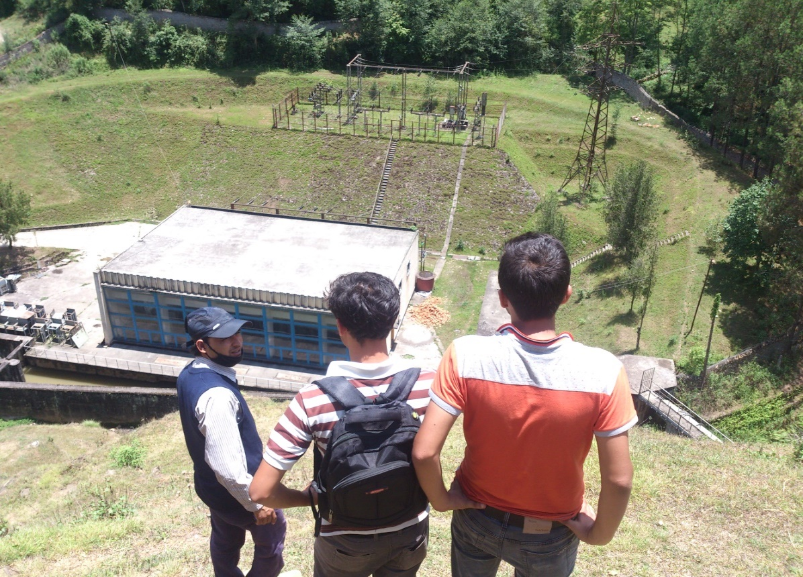

Figure 2 Control station of the plant (observing the sight)

## SECONDARY SOURCES OF DATA COLLECTION

For the extra information and pre-data, we will use secondary source of data collection. We will consult books related to hydraulic design, previous relevant documents, maps etc.

### LIBRARY RECORDS

From the library record, we will get the information of the past problems related to the project like landslide and earthquake data of the project area. We will easily understand the upcoming problems. We will get ideas of solving the preceding difficulties during the project.

### INTERNET

In this modern time, we can easily get information about the problems which are probably occurring and the information which may be useful for techniques and the theories that we will prefer in our project.

# COST MANAGEMENT

We will manage the cost of 2 million dollars. Royalties and taxes will be applied as per provision in the Government of Nepal (GoN) regulation. Royalties or costs associated with construction materials and burrow area have not been considered. The cost for various materials and equipment are listed below with their cost and quantity.

## MATERIALS

The cost of materials required with quantity and price is listed below. These materials are specially required for the lining of canal and its maintenance.

Table 1 Cost management of the material

|  |  |  |  |  |
| --- | --- | --- | --- | --- |
| **S.N** | **Name of materials** | **Quantity**  **(truck)** | **Price**  **(NRs)** | **Total** |
| **1** | Cement | 25 | 7,000 | 175,000 |
| **2** | Sand | 35 | 2,000 | 70,000 |
| **3** | Brick | 12 | 5,000 | 60,000 |
| **4** | Aggregate | 10 | 6,000 | 6,0000 |
| **5** | Steel rod | 40(kg) | 100 | 4,000 |
| **6** | Others |  |  | 55350 |
|  | **Total** |  | | **110,700** |

## EQUIPMENTS

The cost of equipment with their price is listed in table below.

Table 2 Cost management of the equipment

|  |  |  |  |  |
| --- | --- | --- | --- | --- |
| **S.N** | **Name of Equipment** | **Quantity** | **Price** | **Total** |
| **1** | Turbines | 2 | 250,000 | 500,000 |
| **2** | Transformer | 2 | 190,000 | 380,000 |
| **3** | Generator | 2 | 120,000 | 240,000 |
| **4** | Others |  | | 168,000 |
|  | **Total** |  | | **128,800** |

## SALARIES OF PERSONNEL

As per the criteria of the governmentfor the respective posts, the salaries will be provided in time and immediately after the completion of the project.

## TRANSPORTATION

Different materials and equipment have to be carried to the site. So different means of transportation like truck will be used widely. And the transportation cost will be provided as per the nominal rate.

# TIME MANAGEMENT

If our proposal will be approved, we will immediately start our work. The project period is 6 months only sothe time management for the execution of every tasks will be done properly and hence the project can be completed in time.

## MATERIALS

The materials we mention in the tables are all required in the quantity we specified. Our work for lining will begin on Mangsir. The weather will be good at that time. The lining will take about 2 weeks. During this period, the electricity production will be totally off and we will try to finish the work as soon as possible.

## EQUIPMENTS

During the lining process, the required equipment will be replaced. The replacing task will be done by our second technical team. If the equipment are available in time that we have mentioned, the work will be finished within a month.

## WEATHER

As we have mentioned that our working schedule will be started on Mangsir, the work will be rushed unless there is no any bad weather conditions. The winter will be running during our project. So the climate will be cool and dry due to which the work can be performed easily with higher efficiency. Therefore, our work will be finished on time as the time periodthat we have selected for the project is very appropriate.

# CONCLUSION

This work will be too much helpful at this moment. The problem in this plant is not actually of present, from about 6 years many consumers are having trouble due to this. This proposal helps in fixing the problems mentioned earlier.

Increased load shedding problems somehow will be decreased and establishment of the factories and closed factories will be in operation after this. Once the investment is done there will no lose actually as this is the income generating work. Many Nepali skilled, semi-skilled and unskilled workers will get an opportunity of employment during maintenance of the hydropower and to some extent after maintenance that strengthens local economy.

# REFERENCES

Design of Hydraulic structure, S.K. Duggal

Report on Mini Hydropower at Upper Bari, R.K. Rajput

Principle of Hydropower, S.K. Chand

Irrigation and Canal Design, Ramamrutham